Department of Geography

CCST9083 Earth as Seen by Satellite

**Laboratory X: Mapping Flooded areas in** **Google Earth Engine**

In this lab exercise, you will use the web-based code editor to generate a flood map in China’s Henan province using Google Earth Engine. To access the Code Editor, simply browse for <https://code.earthengine.google.com/>.

Radar images from Sentinel-1 *(Sentinel-1 SAR GRD: C-band Synthetic Aperture Radar Ground Range Detected, log scaling)* will be used for this study, and more details can be explored by searching for the data in the search box. A window with a description of the data will open.

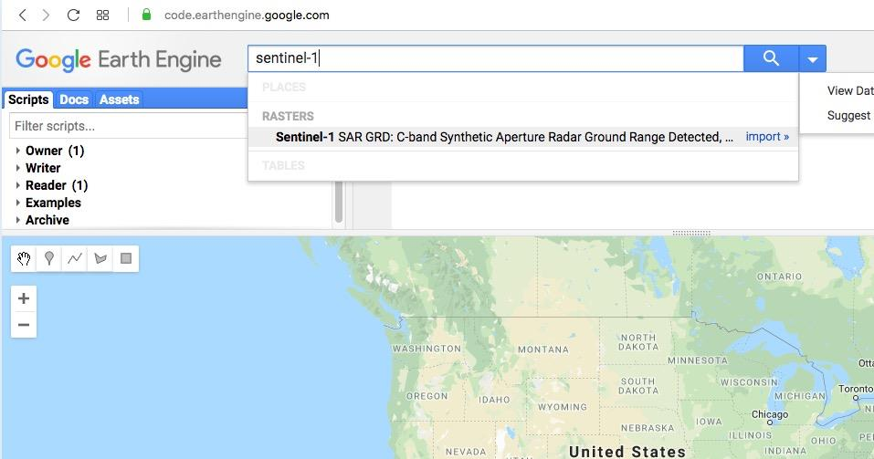

1. **Area of interest**

Our study is focused on floods that occurred in July of 2021 in Henan province, China. Draw a rectangle or polygon covering **Zhengzhou and Xinxiang**. The geometries drawn on the map will automatically be reflected in the Code Editor.

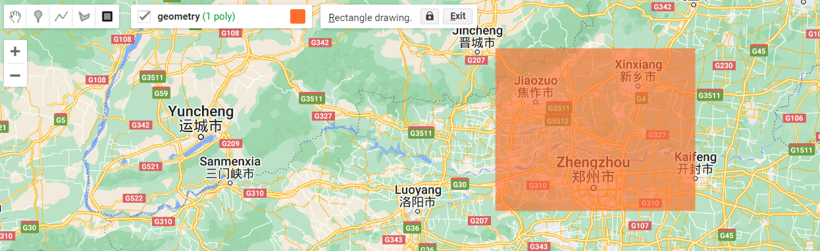



1. **Filter the Sentinel-1 Data by Area**

Load Sentinel-1 C-band SAR Ground Range collection through the code below:

|  |
| --- |
| // Load Sentinel-1 C-band SAR Ground Range collection (log scaling, VV co-polar)  var collection = ee.ImageCollection('COPERNICUS/S1_GRD')  .filterBounds(geometry)  .filter(ee.Filter.listContains('transmitterReceiverPolarisation', 'VV'))  .select('VV');  print(collection, 'Collection');  Map.centerObject(collection,9); |

Click **Run** button in the top menu. The right window will show the results for VV (834 images) in selected study area.

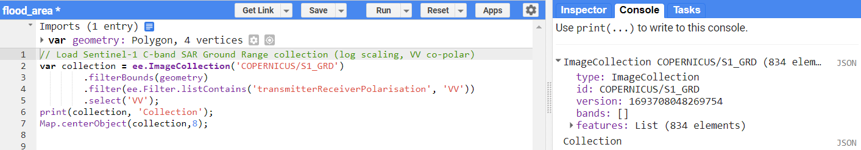

1. **Filter the Sentinel-1 Data by Date**

Filter the Sentinel-1 Data during the flood period (July, 2021):

|  |
| --- |
| // Filter by date  var before = collection.filterDate('2021-06-25', '2021-07-10').mosaic();  var after = collection.filterDate('2021-07-16', '2021-07-30').mosaic();  print(before, 'Before');  print(after, 'After'); |

Click **Run** button in the top menu. The right window will show the results in selected study area before and after flooding.

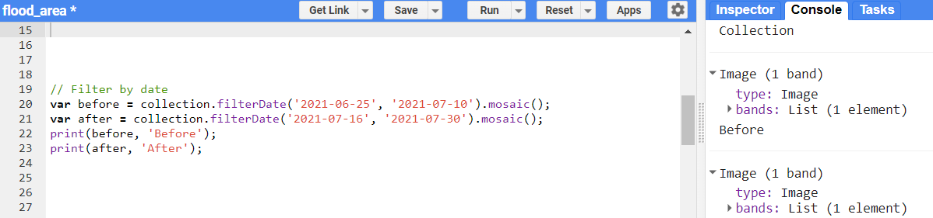

1. **Display the Sentinel-1 Data**

|  |
| --- |
| Map.addLayer(before, {min:-30,max:0}, 'Before flood');  Map.addLayer(after, {min:-30,max:0}, 'After flood'); |

Click the **Run** button in the top menu. The map window will display the Sentinel-1 images. Layer manager enables you to check different layers.

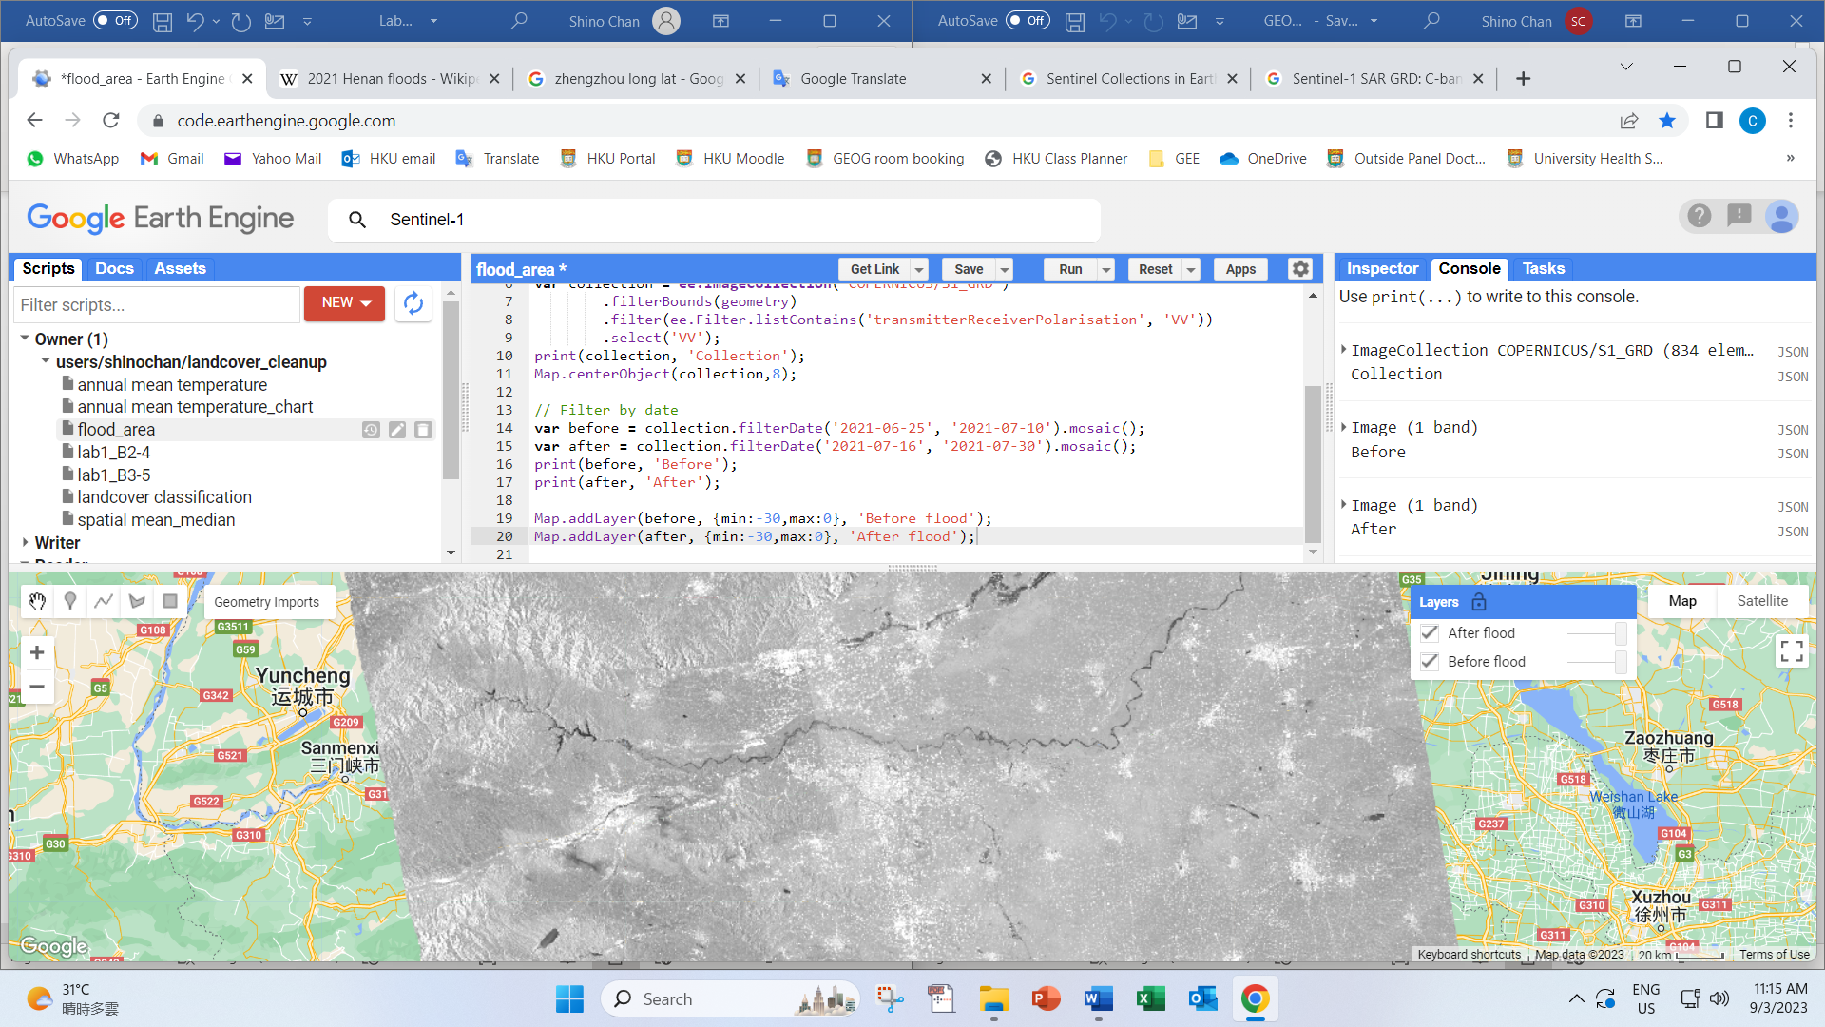

1. **Apply smoothing filter**

Smoothing filter is used to calculate the difference between ‘Before’ and ‘After’:

|  |
| --- |
| //Apply filter to reduce speckle  var diff = after.subtract(before);  Map.addLayer(diff, {min:-10,max:10}, 'After - before', 1);  var SMOOTHING_RADIUS = 100;  var diff_smoothed = after.focal_median(SMOOTHING_RADIUS, 'circle', 'meters')  .subtract(before.focal_median(SMOOTHING_RADIUS, 'circle', 'meters'));  Map.addLayer(diff_smoothed, {min:-10,max:10}, 'diff smoothed', 1); |

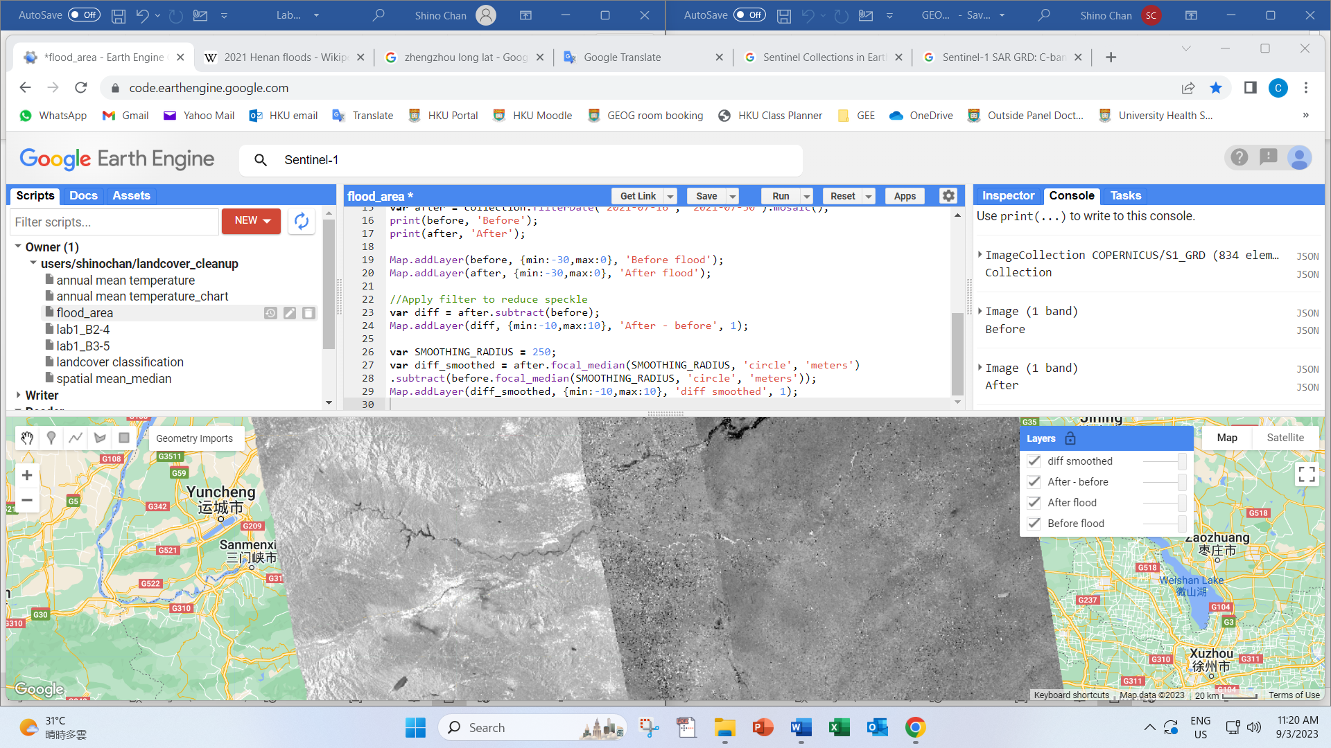

1. **Apply a Threshold**

Apply a threshold to identify flood areas:

|  |
| --- |
| var DIFF_UPPER_THRESHOLD = -3;  var diff_thresholded = diff_smoothed.lt(DIFF_UPPER_THRESHOLD);  Map.addLayer(diff_thresholded.updateMask(diff_thresholded), {palette:"0000FF"},'flooded areas - blue',1); |

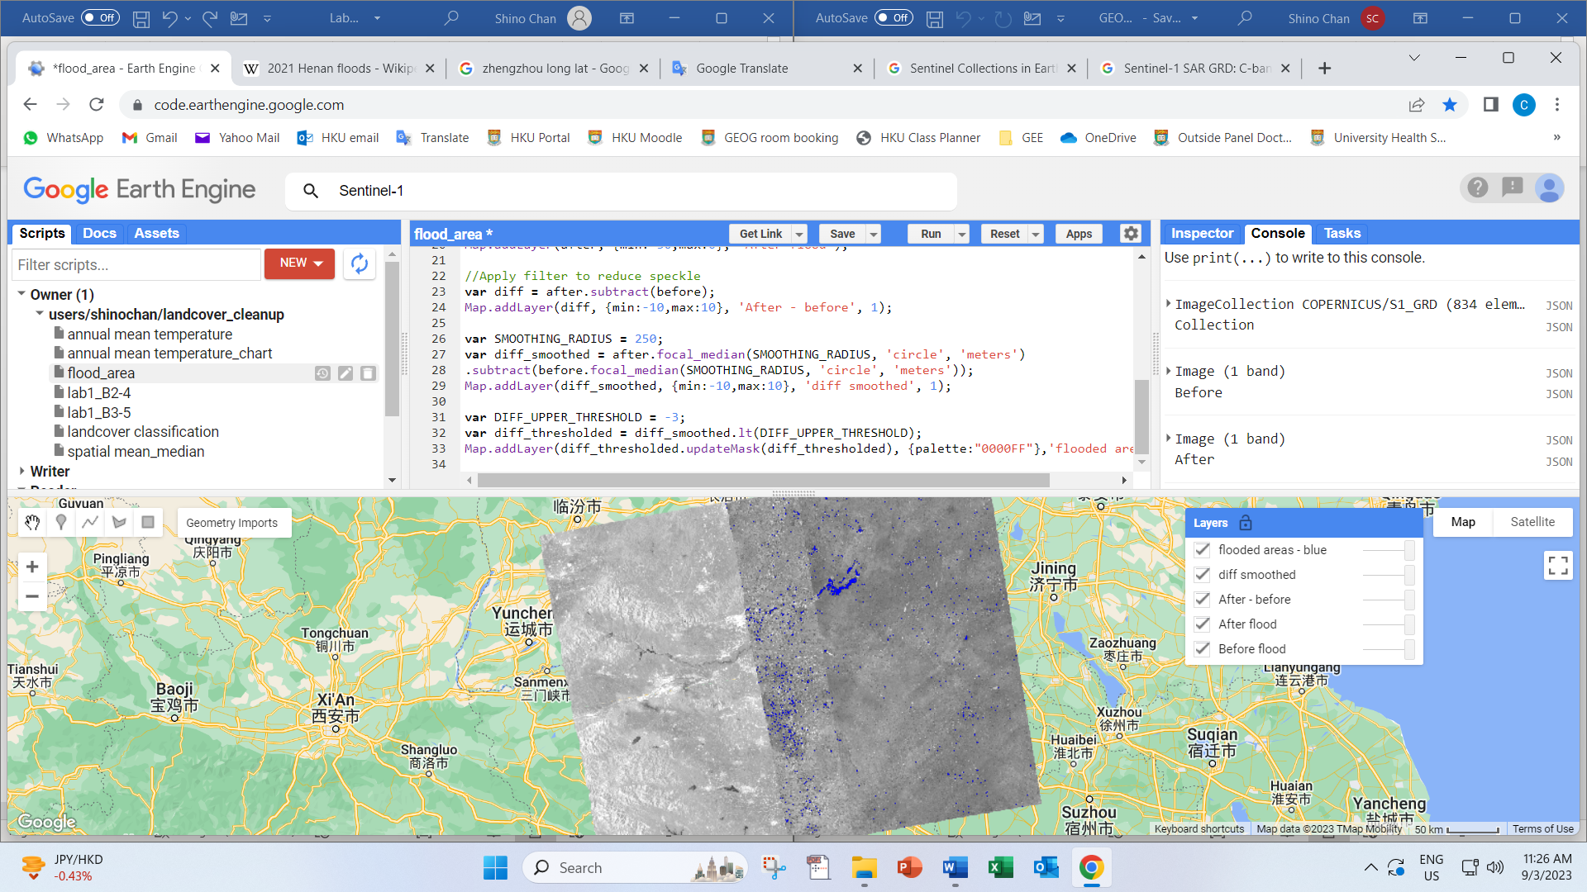

1. **Display flood map**

Go to the Layers manager, untick all the layers except the **‘flooded areas – blue’**. Then toggle full-screen view.

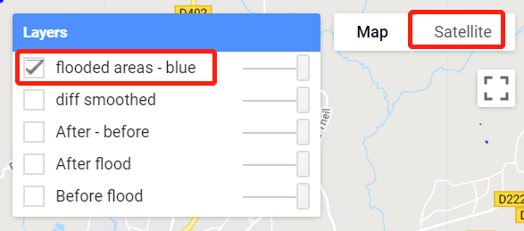

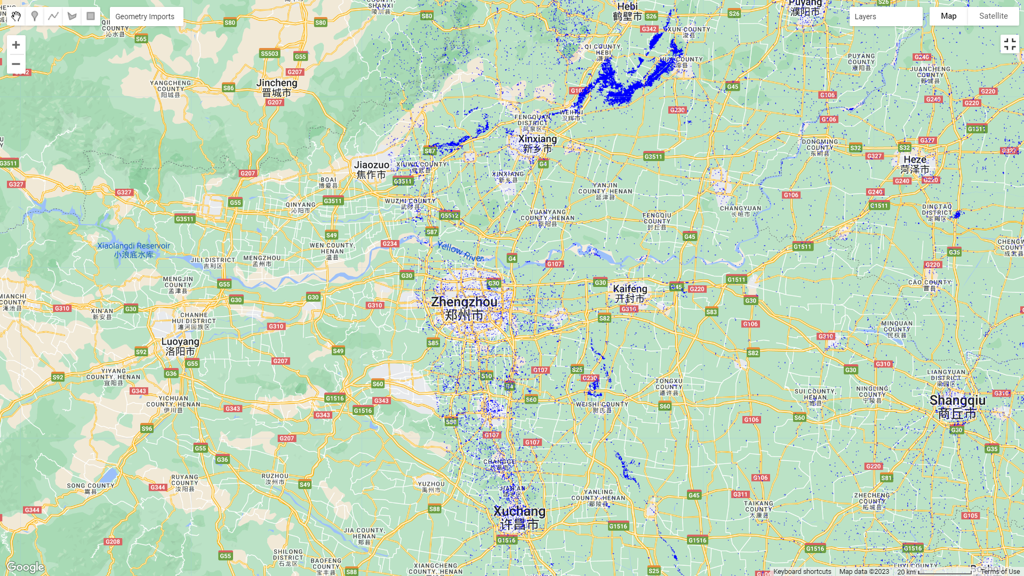

1. **Save and get the link.**

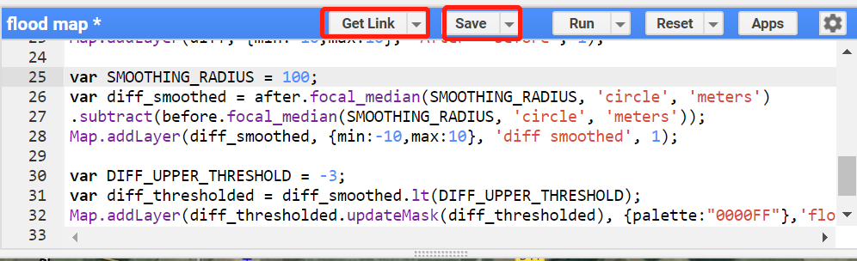

< End >